Explanation of rules tested

1. Attendance Rule Checker
This rule checks if a student was late and whether they brought an excuse letter. The logical statement is:
If a student is late, then they must bring an excuse letter.
If the student indicates being late but fails to provide an excuse letter, the rule is violated. Otherwise, the rule is satisfied.
2. Grading Rule Checker
This rule determines whether the student passed the subject. It follows the logic:
If a student’s grade is 75 or above, then the student passes.
If the input grade is below 75, the rule outputs “Violated ❌” since the student did not meet the passing requirement.
3. Login System Rule Checker
This simulates a basic authentication logic where the correct password grants access. The rule can be stated as:
If the password entered is correct, then access is granted.
If the password is incorrect, the system marks the rule as violated.
4. Academic Status Rule Checker (New Rule)
This is the newly added rule in the system. It determines a student’s academic standing based on their GPA. The logic states:
If a student has a passing GPA, then they must have good academic standing.
The system classifies students as Honors, Regular, Probationary, or At Risk of Dismissal depending on their GPA input. A GPA above 3.00 indicates poor performance and triggers a violation.
5. Bonus Points Checker
This rule evaluates whether a student qualifies for bonus points based on attendance. The logic applied is:
If a student has regular attendance, then they are eligible for bonus points.
Students who do not maintain regular attendance will not qualify and receive a violation result.

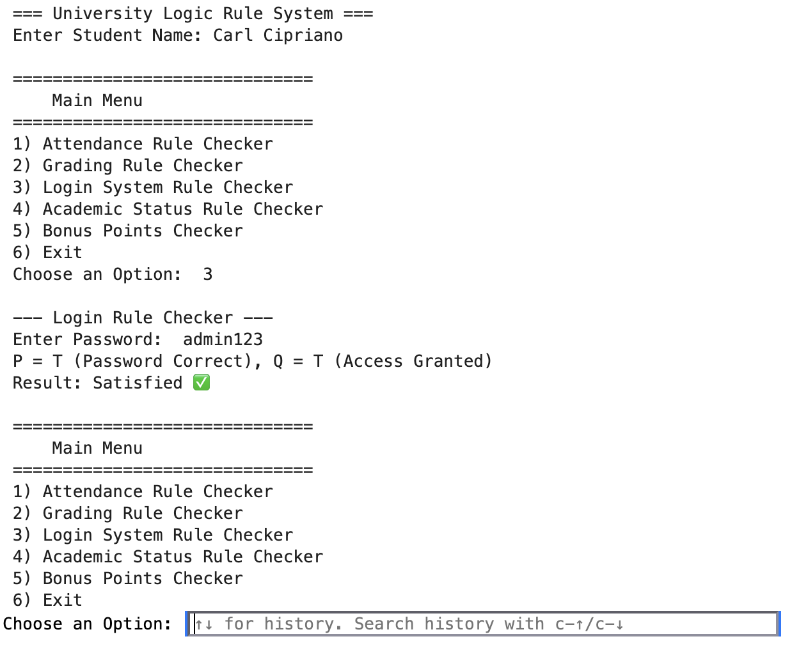
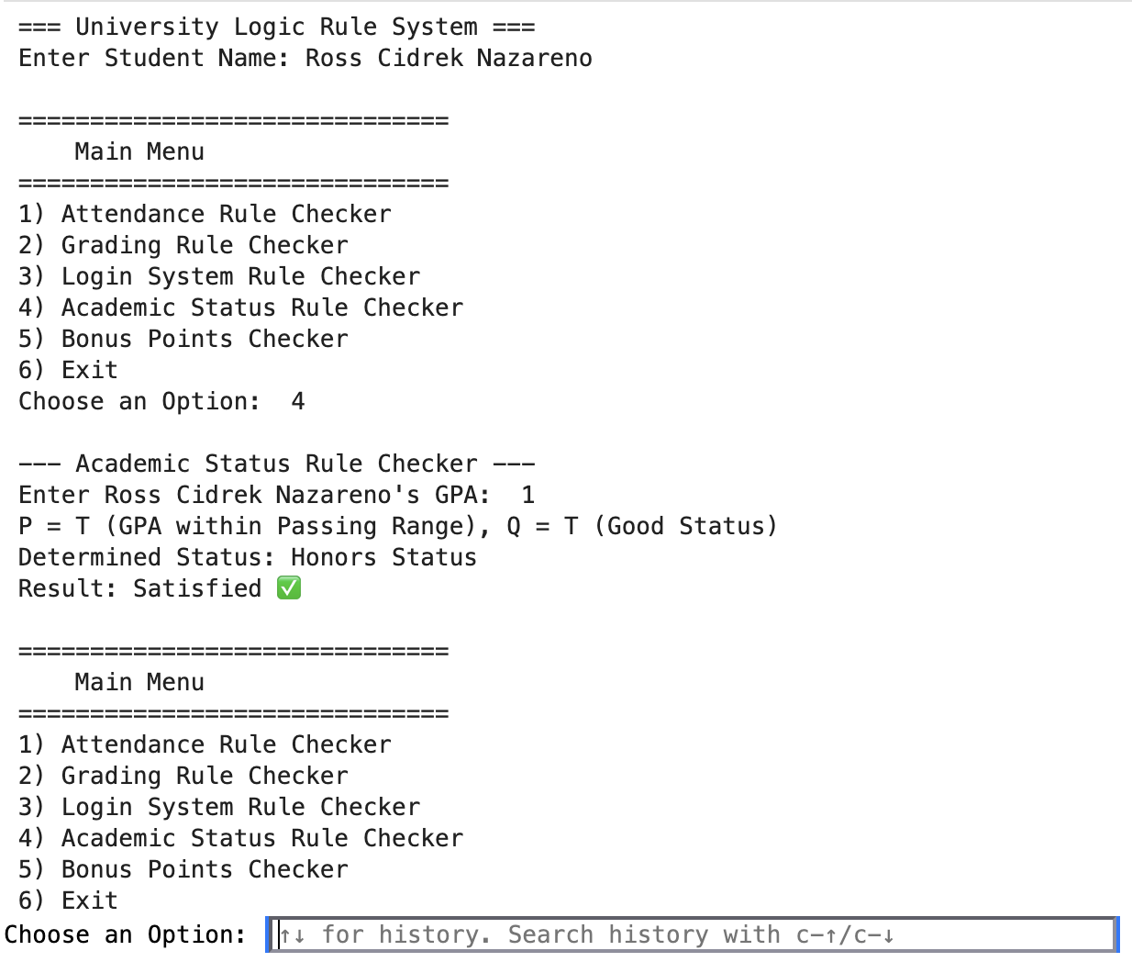
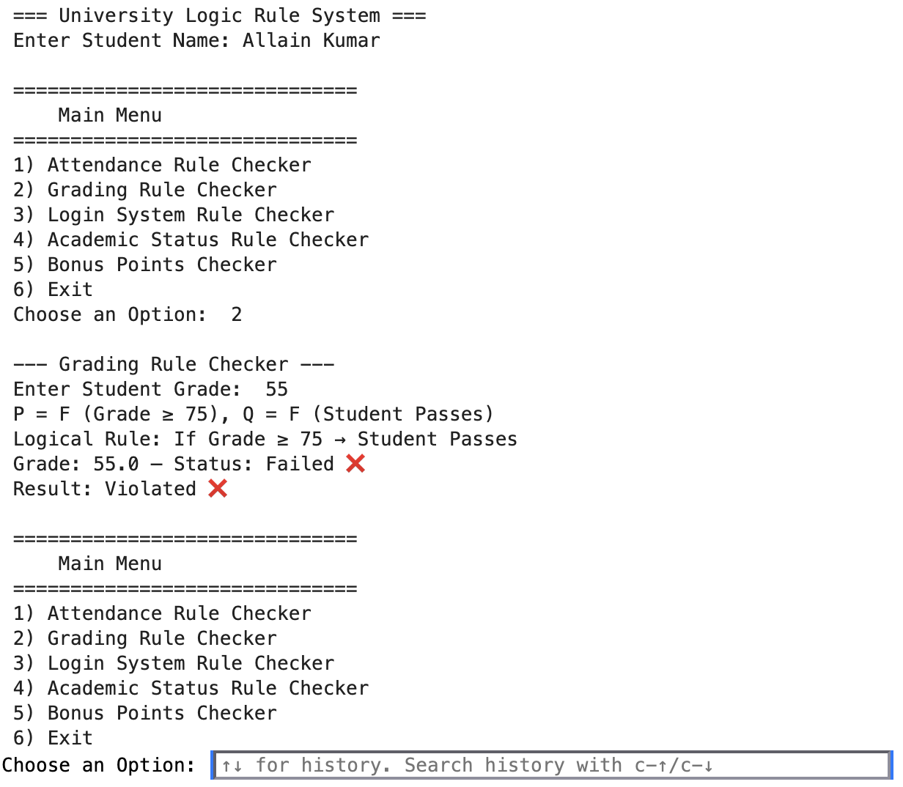
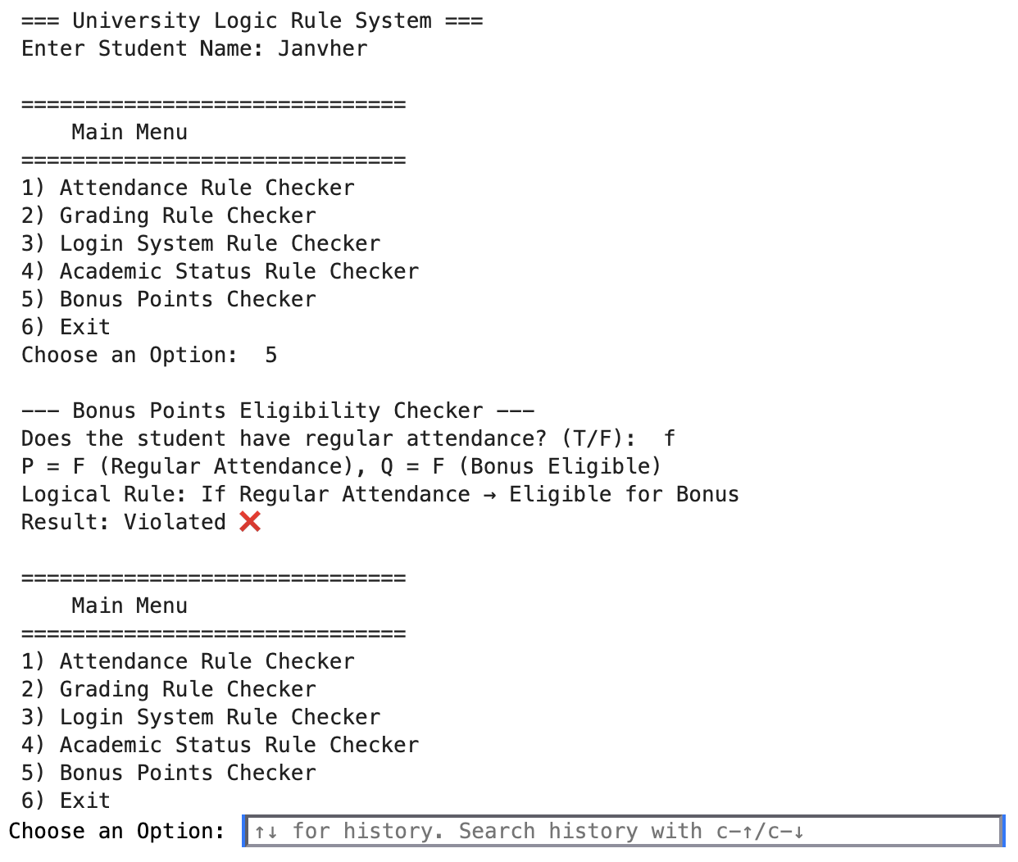
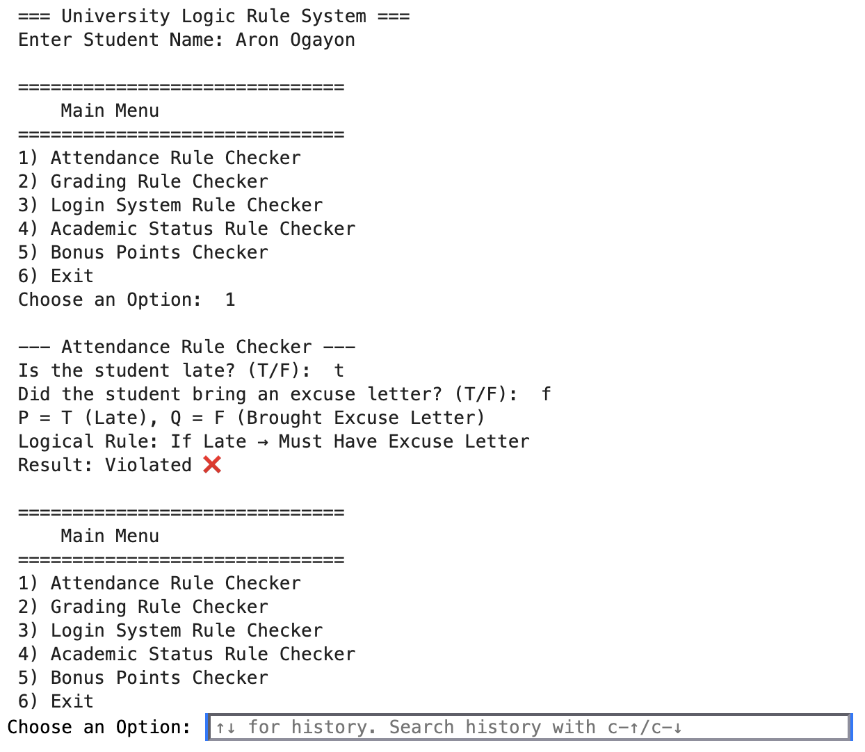
Screenshots of program runs

Description of the added new rule
The Academic Status Rule was designed to expand the system’s logical evaluation capabilities beyond simple pass/fail conditions. It uses GPA as the main input and classifies the student’s academic standing. The rule follows the same structure as the other modules but introduces multi-level output categories to make the evaluation more realistic and aligned with university grading policies.

